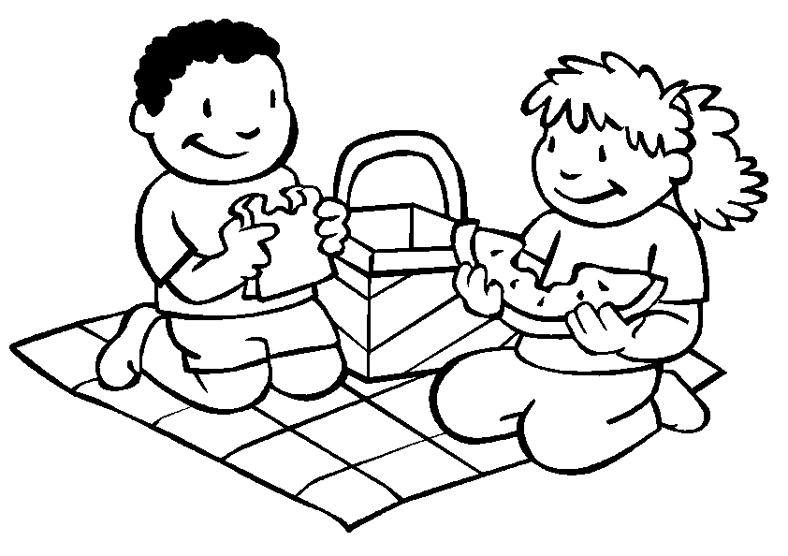
Love each other…
Luke 6:31

